**SECTION 1**

* **SQL script that creates and populates your tables saved as an sql script file (this is a simple text file with a .sql extention). Upload to GitHub. 8 points**

**Answer:**

* **Copy the script in your report. 2 points**

**Answer:**

**CREATE TABLE payment (**

**payment_id VARCHAR(56),**

**total_cost INT(18),**

**total_pay_amount INT(18),**

**method_of_pay VARCHAR(56)**

**);**

**LOAD DATA LOW_PRIORITY LOCAL INFILE 'C:\\Users\\comp\\OneDrive\\Desktop\\payment.csv' REPLACE INTO TABLE `projecthome`.`payment` CHARACTER SET latin1 FIELDS TERMINATED BY ',' OPTIONALLY ENCLOSED BY ',' ESCAPED BY ',' LINES TERMINATED BY '\r\n' IGNORE 1 LINES (`payment_id`, `total_cost`, `total_pay_amount`, `method_of_pay`);**

**CREATE TABLE customer (**

**customer_id VARCHAR(56),**

**customer_name VARCHAR(56),**

**product_name VARCHAR(56),**

**delivery_date date**

**);**

**LOAD DATA LOW_PRIORITY LOCAL INFILE 'C:\\Users\\comp\\OneDrive\\Desktop\\customer.csv' REPLACE INTO TABLE `projecthome`.`customer` CHARACTER SET latin1 FIELDS TERMINATED BY ',' OPTIONALLY ENCLOSED BY ',' ESCAPED BY ',' LINES TERMINATED BY '\r\n' IGNORE 1 LINES (`customer_id`, `customer_name`, `product_name`, `delivery_date`);**

**CREATE TABLE product (**

**product_id VARCHAR(56),**

**product_name VARCHAR(56),**

**quantity VARCHAR(56),**

**price int**

**);**

**LOAD DATA LOW_PRIORITY LOCAL INFILE 'C:\\Users\\comp\\OneDrive\\Desktop\\product.csv' REPLACE INTO TABLE `projecthome`.`product` CHARACTER SET latin1 FIELDS TERMINATED BY ',' OPTIONALLY ENCLOSED BY ',' ESCAPED BY ',' LINES TERMINATED BY '\r\n' IGNORE 1 LINES (`product_id`, `product_name`, `quantity`, `price`);**

**CREATE TABLE product_order (**

**order_id VARCHAR(56),**

**customer_name VARCHAR(56),**

**product_name VARCHAR(56),**

**delivery_date date**

**);**

**LOAD DATA LOW_PRIORITY LOCAL INFILE 'C:\\Users\\comp\\OneDrive\\Desktop\\product_order.csv' REPLACE INTO TABLE `projecthome`.`product_order` CHARACTER SET latin1 FIELDS TERMINATED BY ',' OPTIONALLY ENCLOSED BY ',' ESCAPED BY ',' LINES TERMINATED BY '\r\n' IGNORE 1 LINES (`order_id`, `customer_name`, `product_name`, `delivery_date`);**

**CREATE TABLE supplier (**

**supplier_id VARCHAR(56),**

**supplier_name VARCHAR(56),**

**product_id VARCHAR(56),**

**customer_name VARCHAR(56)**

**);**

**LOAD DATA LOW_PRIORITY LOCAL INFILE 'C:\\Users\\comp\\OneDrive\\Desktop\\supplier.csv' REPLACE INTO TABLE `projecthome`.`supplier` CHARACTER SET latin1 FIELDS TERMINATED BY ',' OPTIONALLY ENCLOSED BY ',' ESCAPED BY ',' LINES TERMINATED BY '\r\n' IGNORE 1 LINES (`supplier_id`, `supplier_name`, `product_id`, `customer_name`);**

* **Screenshots of your populated tables with at least three records from your data files: 10 points**The ‘before’ picture shows an empty table. If it helps, you can merge all images into one screen capture.

**Answer:**

**USE projecthome;**

**SELECT \***

**FROM customer**

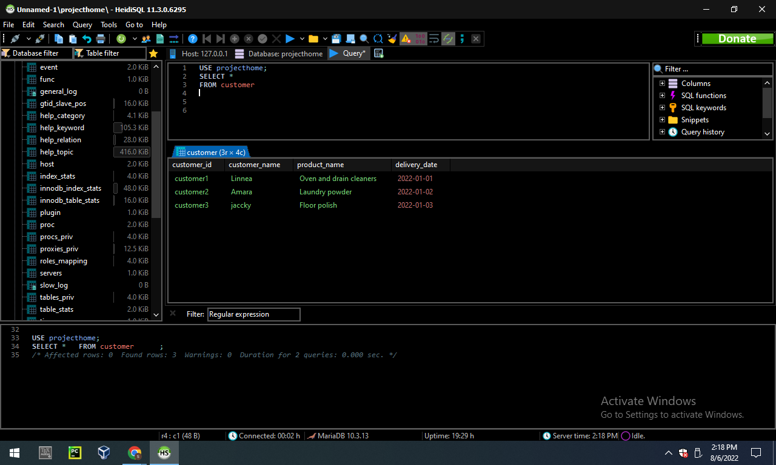

**USE projecthome;**

**SELECT * FROM payment**

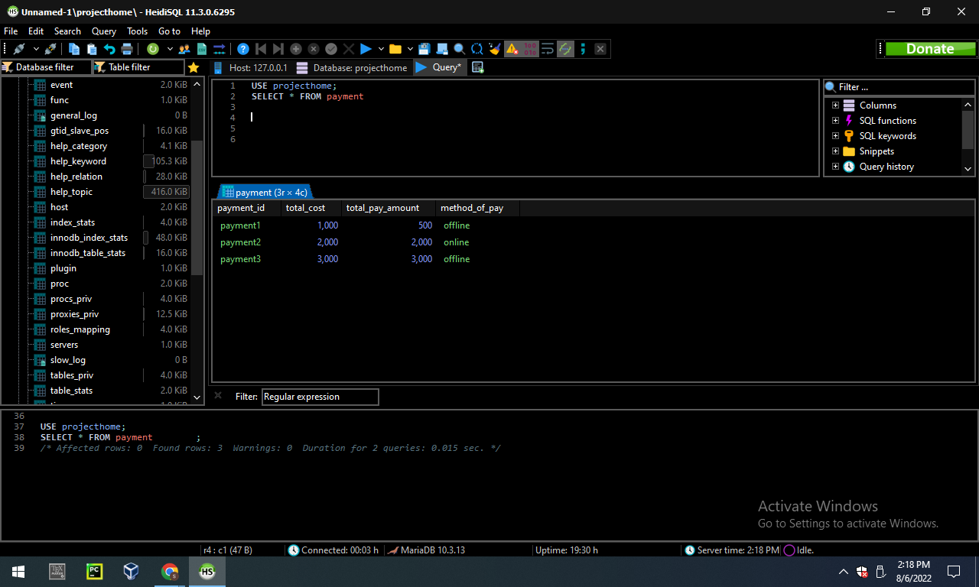

**USE projecthome;**

**SELECT * FROM product**

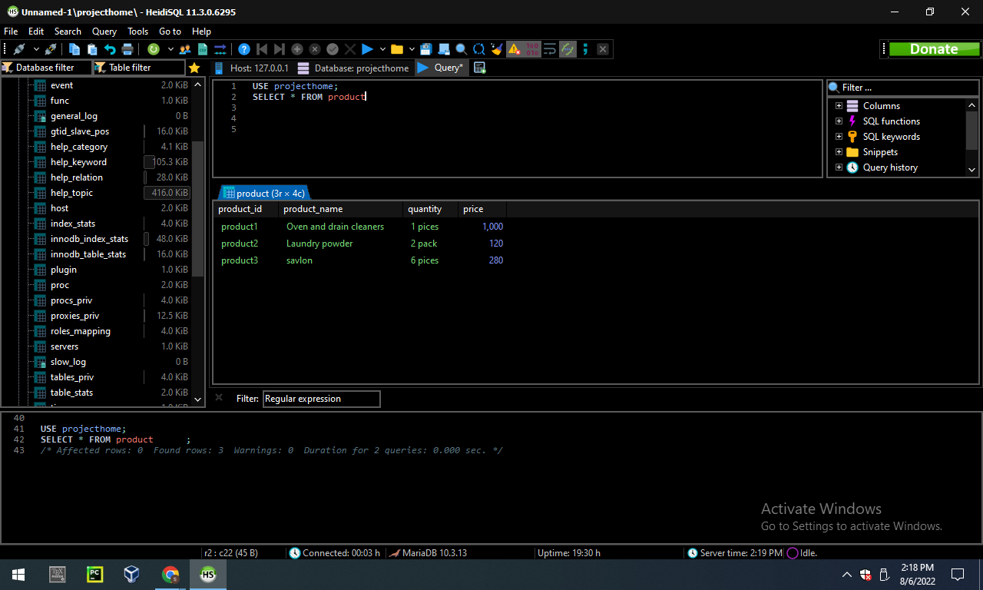

**USE projecthome;**

**SELECT * FROM product_order**

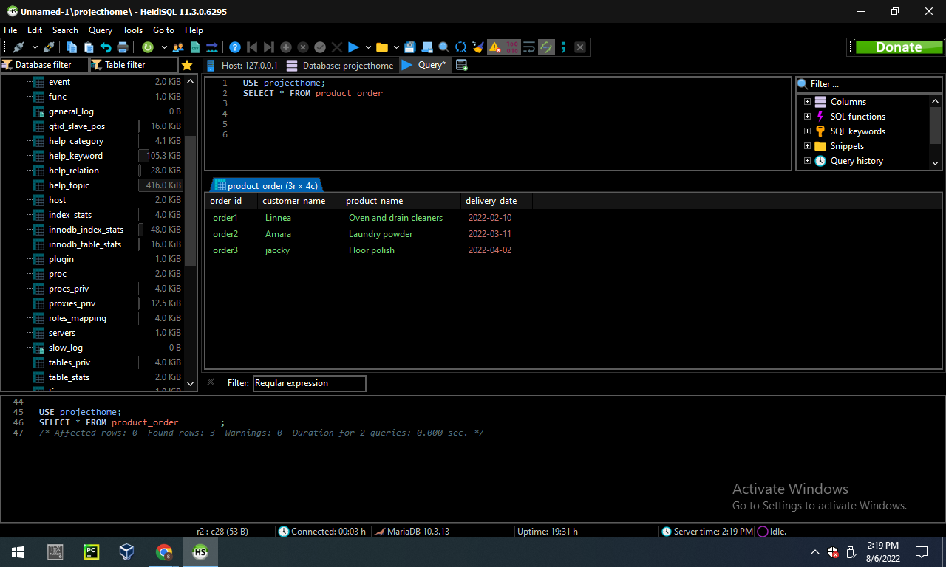

**USE projecthome;**

**SELECT * FROM supplier**

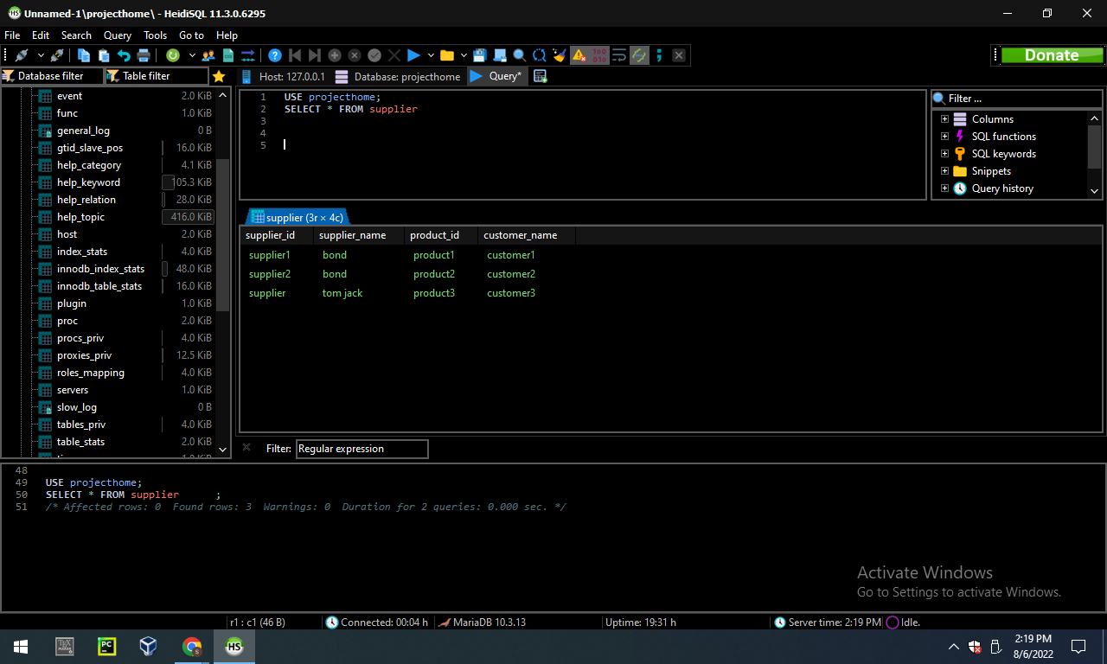

**SECTION 2**

**1 point for one insert statement**

**Answer:**

**INSERT INTO customer(customer_id,customer_name,product_name,delivery_date)**

**VALUES('c4','johnes','home cleaner','2022-2-1')**

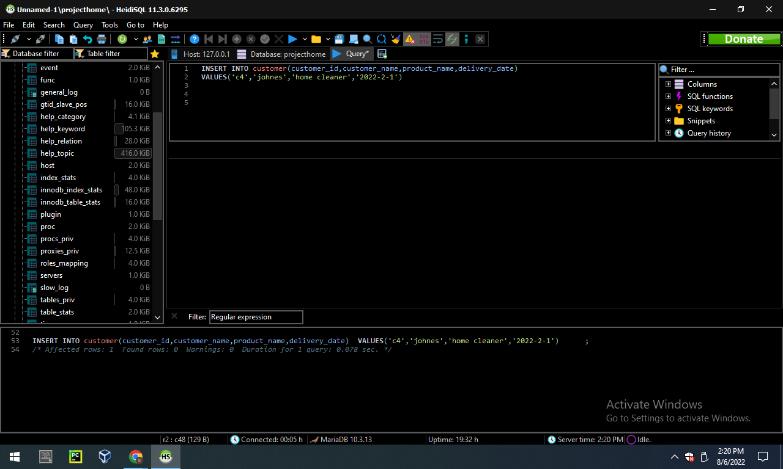

* 1 point for one update statement

**Answer:**

**USE projecthome;**

**UPDATE product**

**SET product_name='savlon',quantity='6 pices' ,price=280**

**WHERE product_id='product3';**

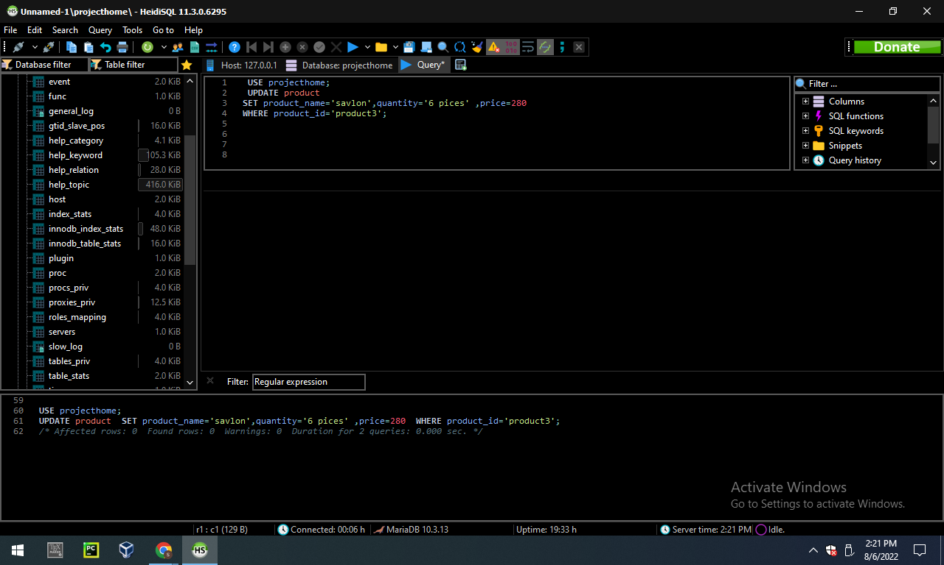

* 1 point for using the delete statement (1 pt)

**Answer:**

**DELETE FROM customer WHERE customer_id='c4';**

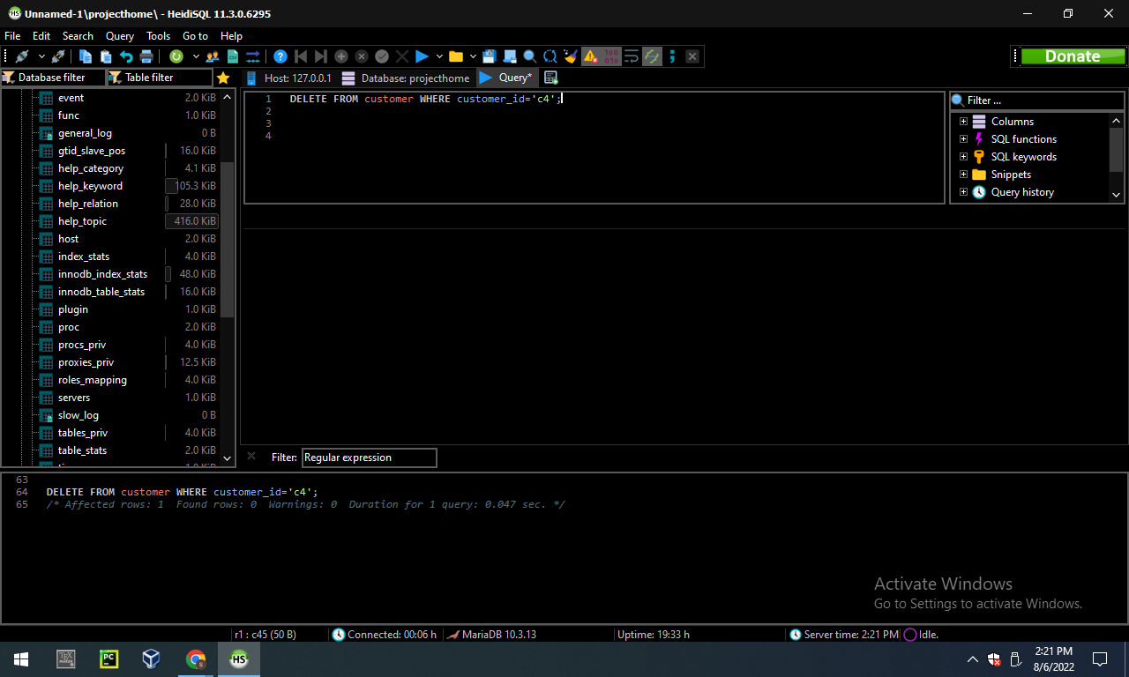

* 1 point for select with ORDER BY statement (1 pt)

**Answer:**

USE projecthome;

SELECT supplier_name,product_id

FROM supplier

ORDER BY supplier_name, customer_name desc

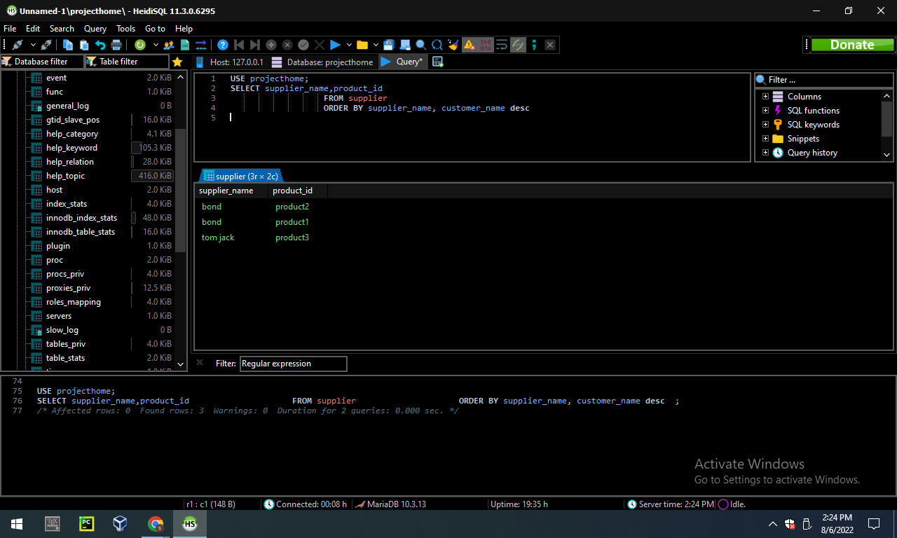

* 1 point for select with a filtering condition using ‘WHERE’

**Answer:**

**USE projecthome;**

**SELECT customer_name**

**FROM product_order**

**WHERE customer_name='Linnea';**

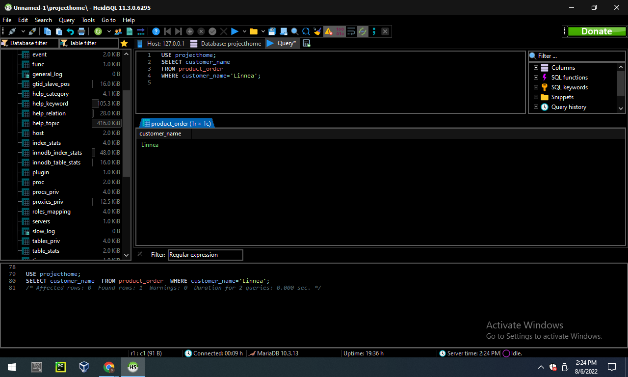

* 2 points for using the join statement

**Answer:**

**USE projecthome;**

**SELECT customer.customer_id, product_order.customer_name**

**FROM customer**

**INNER JOIN product_order ON customer.customer_id=product_order.product_name;**

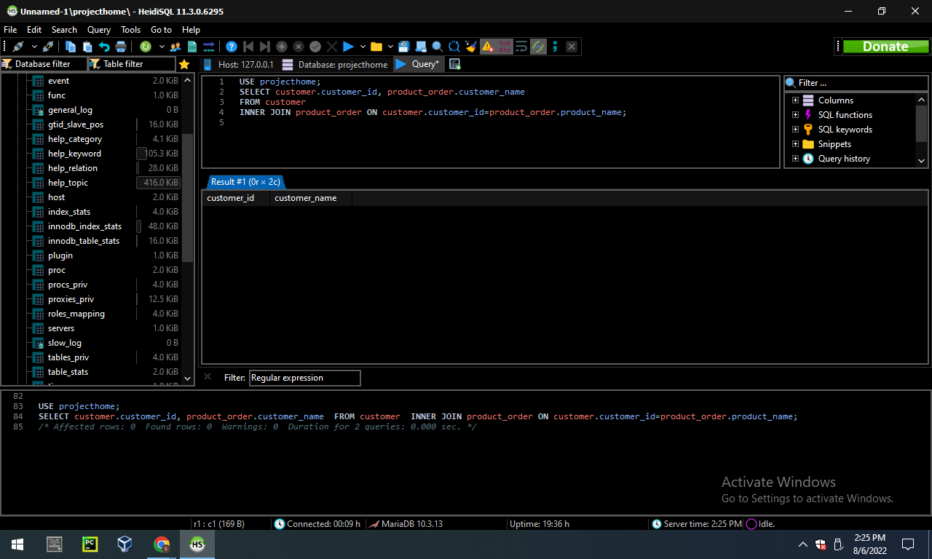

* 6 points each for three queries that use DIFFERENT summary statements (max, min, avg, count) (2 pts eachl)  
  You cannot use the same summary statement 3 times.

**Answer:**

**USE projecthome;**

**SELECT MAX(price)**

**FROM product**

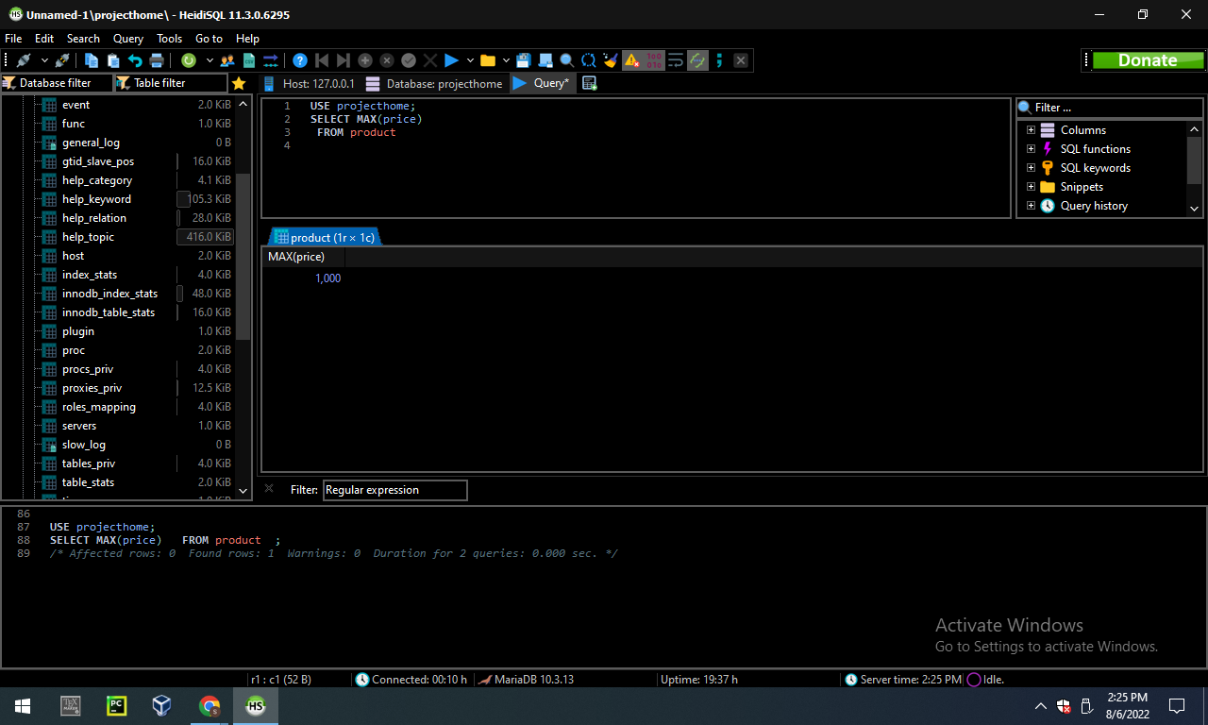

**USE projecthome;**

**SELECT MIN(total_cost)**

**FROM payment**

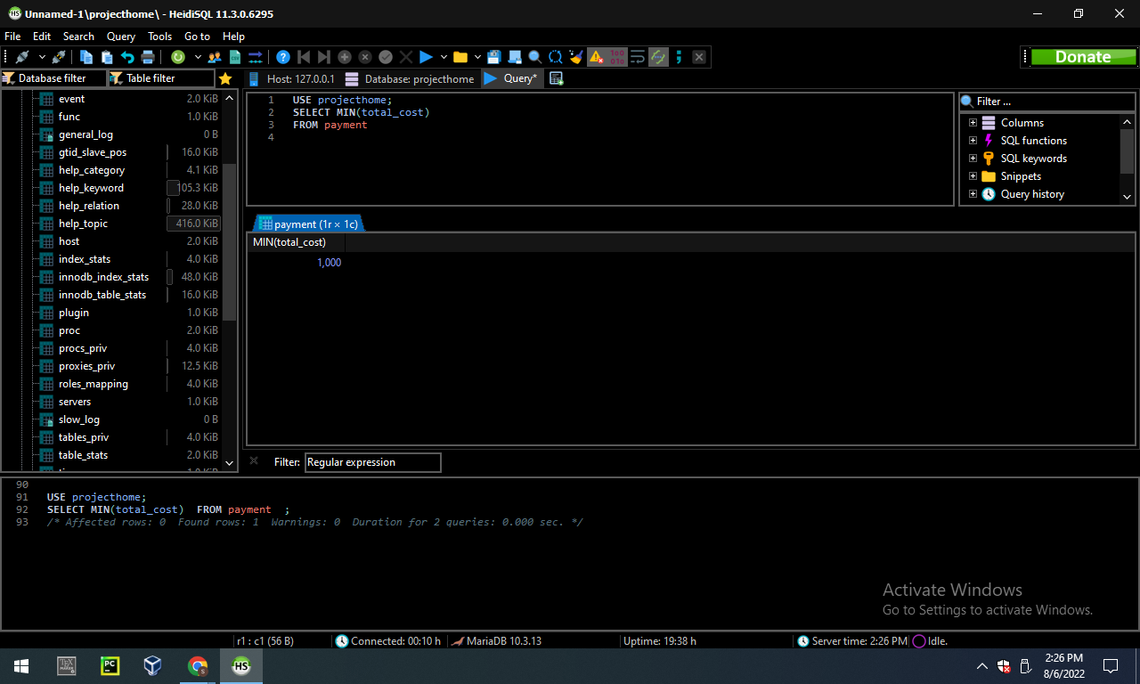

**USE projecthome;**

**SELECT AVG(total_pay_amount)**

**FROM payment**

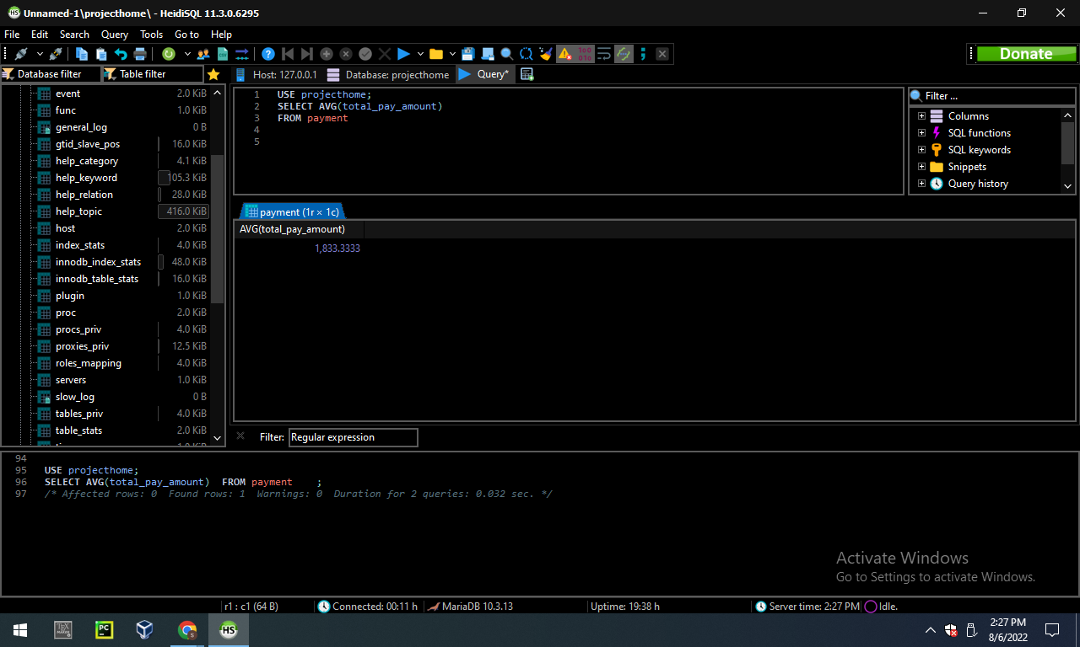

**USE projecthome;**

**SELECT COUNT(customer_name)**

**FROM supplier**

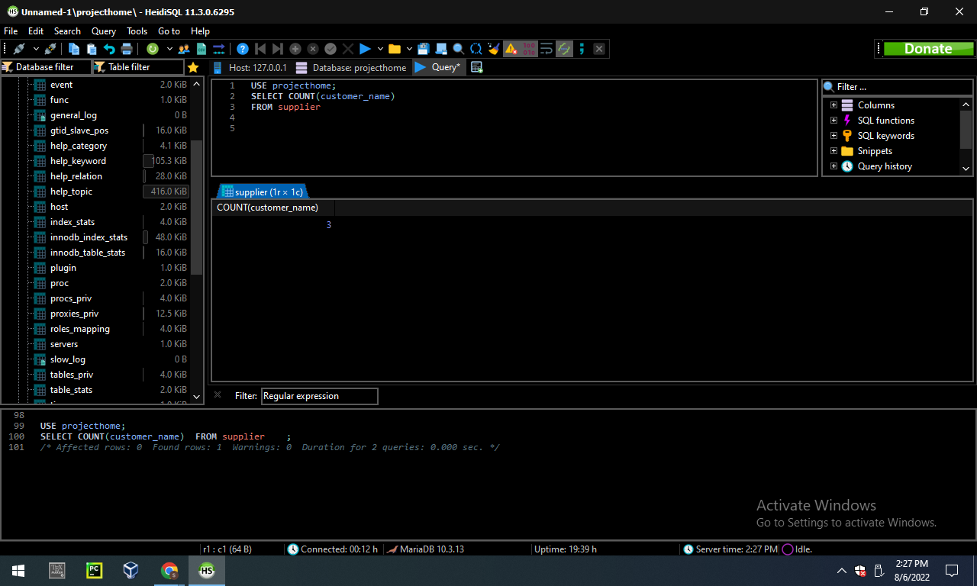

* 2 points for a multi-table query that uses an alias for the output (the ‘as’ keyword)

**Answer:**

USE projecthome;

SELECT price AS product_price

FROM product;

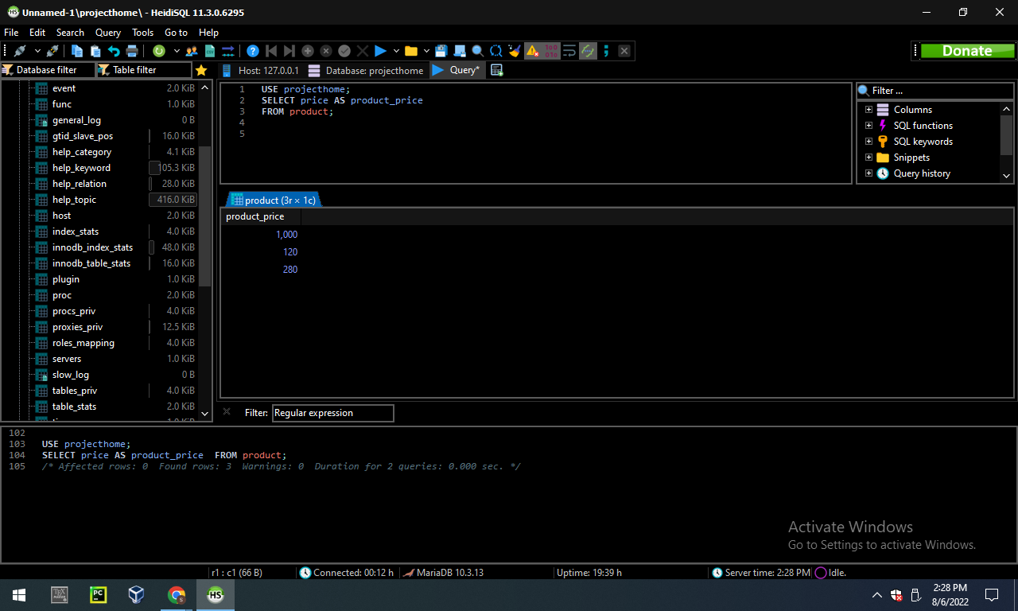

**SECTION 3 – 20 points**

Imagine you are ready to hire someone technical at your company to help administrate the database. Write a paragraph or two (less than a page) explaining what technical resources you need to develop to help your business grow with your database system in terms of

1) handling customer interactions.

Answer.

2) technical components such as language, language implementations, or anything else relevant

3) sales operations

4) administrative maintenance and operations

Answer.

1. A customer interaction is a communication between a business and a customer. High performing customer experience teams interact with customers across the channels of their choice. Beyond emai and the phone, today's customers expect organizations to interact with them where they are, including text , chat , and social engagement. Infact leading customer teams provide their customers with an average of two more channels of engagement than underperforming teams.

2. Advertising language - Advertising Language takes on an expressive function when the sender of the message that means the company advertising its product or services, makes a statement about their history , philosophy and vision. The language of advertising frequently uses figures of speech and other stylish devices that are considered typically of poetic language such as puns , metaphors, neologism , alliteration and assonance or rhyme.

Website - The coding language of HTML makes up the layout and structure of the websites which is dynamic and beautiful using less code for interaction between company and customer. Customers visit the company website and search for products. SQL is a database query language that is used when a company website is computing large amounts of data.

**3.** Sales is about supporting and enabling the frontline sales team to sell more efficiently and effectively by providing strategy direction and reducing friction in the sales process.

4. Sales operation teams accomplish their goal through a variety of roles , functioning and maintaining, strategy and data analysis. One of the main roles of sales operations is to define a high level of vision for the sales organization and develop strategy and maintain strategy to meet goals. Over the past several years there has been an exponentiaL increase in the SaaS applications and other sales tools available to organizations. While better sata and technology can promote sales, complexity of multiple platform can overwhelm sales reps and turn into a timesuck on the sales floorṭherec are few ways of he maintain of salesiperation. These are integration of apps and tools, adoption and customization of CRM ,communication of management and data management and reportings.sales operation contributes to high performance and expertise throughout the sales department by assuming the burden of administration and operational tasks. With the help of data analysis and process optimization , sales operation teams can take the lead on training , hiring and knowledge management to ensure their sales reps have the information and skills to succeed on the sales floor.. Finally, a sales operation seeks to improve performance and productivity by eliminating barriers and smoothing processes for the sales operation. Sales operations maintain some factors. These are implementation of sales methodologies and best practise , identifying KPIs and sales metrics, compensation and incentive plan and lead management.